Early Warning Signal Features Dominate Morphological Predictors in Bacterial Division Prediction: An Interpretable Pipeline with Uncertainty Quantification
Author: Arko Mustafi
Affiliation: Department of Electrical and Electronic Engineering, University of Dhaka,
Supervisor: Dr. S. M. M. A. Mamun
Date: May 2026

Abstract
Antibiotic resistance and phenotypic tolerance constitute an escalating global health crisis, yet the morphological and dynamic features that distinguish individual bacterial cells by physiological state remain incompletely characterized. Existing machine learning approaches to bacterial phenotypic profiling have largely operated as black boxes, limiting biological interpretability and reproducibility. Here we present an interpretable, uncertainty-aware machine learning pipeline for predicting bacterial cell division behavior from short phase-contrast time-lapse sequences, combining classical ensemble models and a fine-tuned convolutional neural network with SHAP feature attribution, Grad-CAM spatial interpretability, Monte Carlo Dropout uncertainty estimation, and conformal prediction coverage guarantees. The pipeline was developed on DeLTA 2.0 mother machine sequences (n=361 cell lineages, 1,454 cell-frame observations) with cross-species morphological validation on three bacterial species from the DeepBacs dataset. XGBoost achieved AUROC=0.974 in five-fold cross-validation and AUROC=0.987 on a held-out test set. SHAP analysis identified lag-1 autocorrelation of growth rate (lag1_autocorr_growthrate) as the dominant predictor across all 150 bootstrap stability resamples (rank 1 in 150/150, mean |SHAP|=2.07±0.10). Both EWS-derived features (lag1_autocorr_growthrate and growthrate_temporal_std) appeared in the top-5 features in 150/150 resamples. Mean phase-contrast intensity also ranked consistently in the top-5 (median rank 2, mean |SHAP|=1.19±0.15) but showed no significant marginal association with division outcome (Mann-Whitney p=0.36), suggesting its SHAP contribution reflects feature interaction effects rather than direct predictive signal. Cross-species morphological profiling of 2,260 cells across E. coli, B. subtilis, and S. aureus confirmed that shape-based features transfer across species while intensity-based features are confounded by imaging modality. These results establish that temporal growth dynamics computed from short observation windows carry substantial predictive information about cell division behavior; whether this signal extends to antibiotic fate prediction under drug exposure conditions remains an open question requiring prospective experimental validation.

1. Introduction
Antimicrobial resistance represents one of the most pressing threats to global public health, with the World Health Organization projecting up to 10 million annual deaths attributable to drug-resistant infections by 2050 (WHO, 2019). A substantial fraction of treatment failures, however, are not caused by genetic resistance but by bacterial persistence — a phenotypic state in which a subpopulation of genetically susceptible cells survives antibiotic exposure through transient growth arrest, resuming replication upon drug removal (Bigger, 1944). Persistent cells are implicated in recurrent and chronic infections including tuberculosis, urinary tract infections, and cystic fibrosis-associated lung infections, and they evade standard susceptibility testing precisely because their tolerance is non-heritable and therefore invisible to genotypic assays.
The persistence phenomenon arises from phenotypic heterogeneity within isogenic bacterial populations: genetically identical cells exposed to the same antibiotic at the same time show different fates, with a small fraction surviving while the majority are killed (Balaban et al., 2004). This heterogeneity has been linked to stochastic variation in growth rate, metabolic activity, and cellular morphology in the pre-treatment state, establishing that fate is not random but partially predictable from the cell's physiological state before drug addition (Levin-Reisman et al., 2017; Ackermann, 2015). The mechanistic basis remains incompletely understood, but the implication is clinically significant: if persistent cells can be identified before antibiotic addition, treatment strategies could be adapted to eliminate them directly rather than relying on repeated drug courses.
Single-cell time-lapse microscopy in microfluidic mother machine devices has emerged as the primary experimental platform for studying persistence at single-cell resolution (Wang et al., 2010). Mother machine devices trap individual bacterial lineages in narrow channels, enabling continuous observation of growth, division, and morphological dynamics over hours or days. Automated image analysis pipelines such as DeLTA 2.0 (Lugagne et al., 2020) now enable segmentation, tracking, and lineage reconstruction at scale, generating structured quantitative data from thousands of individual cell trajectories per experiment and making large-scale ML analysis tractable.
Machine learning approaches to bacterial microscopy have achieved high predictive accuracy in classification and segmentation tasks (Stringer et al., 2021; Jeckel & Drescher, 2021), but existing pipelines are largely opaque: they report what is predicted without explaining which features drove each prediction, do not quantify prediction uncertainty, and have not been validated across species with different morphologies. This limits their scientific utility — a pipeline intended to support downstream biological hypothesis generation must not only classify cells accurately but communicate when its predictions are unreliable and which features carry the most information. No published study has combined interpretable feature attribution (SHAP), pixel-level spatial interpretability (Grad-CAM), instance-level uncertainty quantification (MC-Dropout), and statistically guaranteed prediction intervals (conformal prediction) within a single bacterial microscopy pipeline, nor systematically validated morphological feature transferability across multiple bacterial species within such a framework.
Here we present an interpretable, uncertainty-aware machine learning pipeline for predicting bacterial cell division behavior — specifically, division versus growth arrest — from short phase-contrast time-lapse observation windows. The pipeline extracts 15 features combining DeLTA 2.0 lineage measurements, image-derived morphological descriptors, and early warning signal (EWS) features computed from growth rate time series. Three classifiers were evaluated — Logistic Regression, Random Forest, and XGBoost — with XGBoost achieving AUROC=0.974 in five-fold cross-validation and AUROC=0.987 on a held-out test set. SHAP analysis identified temporal EWS features as the dominant predictors of division outcome, ranked above static morphological features in all 150 bootstrap stability runs, challenging prior emphasis on cell size as the primary informative signal. A ResNet-18 CNN with MC-Dropout provided spatial interpretability via Grad-CAM and instance-level uncertainty estimates. Split conformal prediction yielded valid coverage guarantees at all tested significance levels. Cross-species morphological profiling on DeepBacs confirmed that shape-based features transfer across E. coli, B. subtilis, and S. aureus while intensity-based features are confounded by imaging modality. We note that because features and labels are derived from overlapping observation windows, the EWS features identified here should be interpreted as co-occurring with division activity rather than causally predicting it; a prospective validation design — computing features on early frames and assigning labels from later frames — is required before these signals can be claimed as predictive precursors of division or antibiotic tolerance. The full pipeline is implemented in Python, runs on consumer CPU hardware, and is released as a reproducible Jupyter notebook. This paper is organized as follows: Section 2 describes the datasets and methods; Section 3 reports results; Section 4 discusses biological implications and limitations.

2. Methods

2.1 Datasets
Two publicly available microscopy datasets were used in this study.
DeLTA 2.0 test sequences were obtained by cloning the DeLTA GitLab repository (https://gitlab.com/dunloplab/delta). The pipeline used here is DeLTA 2.0 (O'Connor et al., 2021, PLOS Computational Biology), a significant revision of the original DeLTA framework (Lugagne et al., 2020), which extended automated segmentation and lineage reconstruction to two-dimensional open-field environments in addition to the mother machine. This distinction is methodologically important: the present study uses both a 2D open-field sequence and two mother machine sequences, and DeLTA 2.0's dual-environment capability — with reported error rates around 1% and runtimes under 10 minutes for complete multi-hundred-cell movies — is what makes laptop-executable analysis tractable (O'Connor et al., 2021). The test data comprises phase-contrast time-lapse sequences stored as TIFF image stacks and MATLAB MAT files containing pre-computed segmentation masks and cell lineage data. Three position files were used: one 2D open-field sequence (10 frames, 520×696 pixels) and two mother machine sequences (10 frames per chamber, 18–19 chambers per position). In total, 361 unique cell lineages were extracted across 4 MAT files, yielding 1,871 cell-frame observations and 1,454 rows in the final feature matrix after merging with image-derived features.
Cell division labels were derived from the daughters field of the DeLTA lineage structure. A cell was labelled divided (class 1) if any non-zero value appeared in its daughters array across the observation window, indicating at least one division event. Cells with all-zero daughters arrays were labelled arrested (class 0). This division-based survival proxy is consistent with single-cell approaches in the persistence literature. Baltekin et al. (2017) established that absence of division within a defined observation window is a valid proxy for persistence entry, and subsequent work by Bamford et al. (2017) demonstrated with time-lapse microfluidics that non-dividing cells exhibit phenotypic signatures — including reduced fluorescence from metabolic reporters and altered morphological dynamics — that distinguish them from dividing cells prior to antibiotic exposure. The resulting class distribution in this dataset was 1,071 divided (73.7%) and 383 arrested (26.3%), a 2.8:1 imbalance addressed by the procedures described in Section 2.4. It should be noted that the division-proxy label introduces inherent noise where cells may be arrested due to microfluidic confinement effects rather than physiological persistence. All biological interpretations are qualified accordingly.
DeepBacs (Spahn et al., 2022, Communications Biology) provided static segmentation images for three bacterial species: E. coli (Zenodo record 5550935), B. subtilis (Zenodo record 5550968), and S. aureus (brightfield dataset). DeepBacs is a curated multi-task bacterial microscopy benchmark encompassing segmentation, denoising, and phenotypic profiling tasks across species (Spahn et al., 2022), and was selected here as a cross-species morphological reference. Instance segmentation masks (RoiMap format for E. coli, StarDist format for B. subtilis, brightfield masks for S. aureus) were used to extract per-cell morphological features for a cross-species comparison analysis.
No treatment labels are available in DeepBacs; it was therefore used solely for morphological profiling and species-level feature distribution comparison, not for classification model training or evaluation.

2.2 Preprocessing Pipeline
All phase-contrast images were preprocessed using a two-step pipeline implemented in src/preprocessing.py.
Step 1 — Background subtraction. The rolling-ball algorithm (Sternberg, 1983) was applied with radius=25 pixels using skimage.restoration.rolling_ball. Phase-contrast microscopy produces images in which bacteria appear as dark objects on a medium-gray background due to optical path-length differences, and uneven illumination across the field of view — characteristic of the mother machine geometry — requires explicit correction. To handle this phase-contrast polarity, the image was first shifted to a non-negative range before background estimation. The corrected image was computed as corrected = (img - img.min()) - background. A rolling-ball radius of 25 pixels was selected to match the spatial scale of illumination variation without inadvertently subtracting cell body signals (typical E. coli widths are 1–3 µm, well below the correction scale).
Step 2 — Z-score normalization. The background-subtracted image was normalized to zero mean and unit standard deviation: img_final = (img - mean) / std. Applying normalization after background subtraction guarantees mean=0 and std=1 by construction, which was verified across five test frames (mean within ±0.0001 of zero, std=1.0000 exactly). This ordering — background subtraction first, normalization second — is essential; reversing the order would cause intensity-normalized images to retain spatially structured illumination artefacts that inflate optical feature variance non-uniformly across the field.
For the DeLTA mother machine data, segmentation masks were taken directly from the pre-computed labelsstack field in the MAT result files rather than running Cellpose independently. DeLTA 2.0's segmentation model was trained specifically on this image type, and using its output as ground-truth segmentation avoids the additional hyperparameter sensitivity of a secondary segmenter. This decision is consistent with the methodology adopted in DeLTA's original benchmarking experiments (O'Connor et al., 2021), where DeLTA's own masks were used as reference for downstream lineage analysis.

2.3 Feature Extraction
Eighteen features were extracted per cell per frame from three sources: the DeLTA lineage structure, image-derived measurements applied via skimage.measure.regionprops, and temporally derived early warning signal (EWS) statistics.

Table 1. Feature summary
Feature | Source | Category
area | DeLTA lineage | Morphological
width | DeLTA lineage | Morphological
length | DeLTA lineage | Morphological
perimeter | DeLTA lineage | Morphological
growthrate_l | DeLTA lineage | Dynamic
growthrate_a | DeLTA lineage | Dynamic
old_pole_y, old_pole_x | DeLTA lineage | Positional
new_pole_y, new_pole_x | DeLTA lineage | Positional
mean_intensity | Image-derived | Optical
std_intensity | Image-derived | Optical
cv_intensity | Image-derived | Optical
aspect_ratio | Image-derived | Morphological
eccentricity | Image-derived | Morphological
pole_asymmetry | Image-derived | Optical
lag1_autocorr_growthrate | EWS-derived | Temporal
growthrate_temporal_std | EWS-derived | Temporal
was_ejected | DeLTA lineage | Positional

Image-derived features were extracted by applying the preprocessed image to the DeLTA segmentation masks using skimage.measure.regionprops. The coefficient of variation of intensity (cv_intensity) was clipped at its 99th percentile (26.36) to remove numerical artefacts arising from near-zero mean intensity in small cells.
Early Warning Signal (EWS) features. Two features were computed per cell lineage motivated by critical slowing down (CSD) theory. As a dynamical system approaches a bifurcation — analogous to a bacterial cell approaching the transition into a non-dividing persistent state — its recovery rate from perturbations decreases, producing a characteristic rise in lag-1 autocorrelation and variance in time series data (Scheffer et al., 2009; Dakos et al., 2015; Veraart et al., 2011). The lag-1 autocorrelation of length-based growth rate (lag1_autocorr_growthrate) was computed as the Pearson correlation between consecutive growth rate values within each cell's observation window. The temporal standard deviation of growth rate (growthrate_temporal_std) measures intra-lineage variability. Both features are computed as cell-level constants (identical for all frames of the same cell) and attached to each cell-frame row for consistency with the feature matrix structure.
Critical limitation. With only 10 frames per cell, these EWS features are statistically unreliable. The CSD literature establishes that meaningful autocorrelation-based early warning detection requires a minimum of 50 time points to distinguish signal from noise (Dakos et al., 2012; Boettiger & Carpenter, 2012). At 10 frames, the estimated autocorrelation has high variance and sensitivity to individual outlier frames. Furthermore, Titus et al. (2020) demonstrated that some systems approaching tipping points exhibit "critical speeding up" rather than slowing down — a drop in autocorrelation and variance — meaning that the directional expectation for these features is not guaranteed a priori in bacterial persistence. Results involving EWS features are therefore treated as exploratory indicators rather than validated predictors. SHAP stability analysis (Section 2.5) is used to empirically assess whether these features provide consistent signal across bootstrap resamples, and their prominence in SHAP rankings is interpreted with this caveat. Future iterations of this pipeline with 50+ frame time-lapse data would be required to validate EWS features as reliable persistence predictors.
Observation window confound. A further constraint applies specifically to the EWS features and to the AUROC reported for all models. Both lag1_autocorr_growthrate and growthrate_temporal_std are computed over the same 10-frame observation window from which the division label is derived: a cell is labelled "dividing" if a division event occurs within that window, and both EWS features summarize growth rate dynamics within that same window. A cell that is actively dividing during the observation period will by construction exhibit high growth rate variance and non-zero autocorrelation as a consequence of the division process itself, not as a precursor to it. This means the EWS features co-occur with the division label rather than preceding it, and the high AUROC values reported in Section 3 should be interpreted accordingly — as measures of discriminative co-occurrence, not prospective prediction. A valid prospective design would compute all features on frames 1 to N and assign labels from frames N+1 onward, with a temporal gap sufficient to exclude division-phase dynamics from the feature window. This design is not achievable with the current 10-frame sequences and is identified as the primary methodological priority for future work.

2.4 Machine Learning Models
Three classical classifiers were evaluated: Logistic Regression, Random Forest (200 trees), and XGBoost (200 estimators). All models used class_weight= 'balanced' or equivalent to address the 2.8:1 class imbalance.
Class imbalance. Imbalanced datasets systematically bias classifiers toward the majority class, degrading minority-class recall (Fernández et al., 2018). Class imbalance was addressed using two complementary strategies: (i) class_weight='balanced' in all classifiers, and (ii) SMOTE (Synthetic Minority Over-sampling Technique; Chawla et al., 2002). SMOTE generates synthetic minority samples by linear interpolation between k-nearest neighbors in feature space (Elreedy & Atiya, 2019). The 3:1 imbalance ratio in this dataset falls within the range where standard SMOTE with balanced class weighting has been shown to substantially improve minority-class recall without inducing noise at class boundaries (Fernández et al., 2018).
SMOTE was applied exclusively to training folds and never to validation or test data — a methodological requirement that prevents information leakage and is not uniformly observed in published work. In practice this was implemented by applying SMOTE manually within a custom cross-validation loop, not embedded in the sklearn Pipeline object. This is non-trivial: certain sklearn and imbalanced-learn version combinations silently apply SMOTE to validation data when using the Pipeline API, inflating cross-validation performance estimates. The custom loop implementation was verified by inspecting fold indices at each iteration to confirm no test-fold samples appeared in the SMOTE fit.
Model selection used 5-fold stratified cross-validation with four metrics: balanced accuracy, AUROC, macro F1, and Matthews Correlation Coefficient (MCC). MCC is recommended as a single robust metric for binary imbalanced classification problems, being sensitive to all four quadrants of the confusion matrix and unaffected by class distribution (Chicco & Jurman, 2020). A stratified 80/20 train/test split was used with the 20% held-out set never accessed during model selection. The best-performing model (XGBoost, AUROC=0.974 in cross-validation, AUROC=0.987 on held-out test) was selected for interpretability analysis.
Cautionary note on performance figures. An AUROC of 0.987 on a dataset of 1,454 cell-frame observations with a 10-frame observation window is high enough to warrant scrutiny. Several factors may contribute to inflated apparent performance: (i) the division-proxy label may be partially correlated with structural features of the microfluidic chamber (e.g., was_ejected, pole position) rather than intrinsic persistence biology; (ii) the EWS features, being cell-level constants repeated across all frames of a cell, introduce within-cell temporal autocorrelation that the train/test split does not fully account for unless splits are performed at the cell level, not the cell-frame level. Cell-level splitting is implemented in this study but noted explicitly as a confound to monitor in downstream validation on larger datasets.

2.5 Interpretability Methods
SHAP. Feature importance was assessed using SHAP TreeExplainer (Lundberg & Lee, 2017) applied to the fitted XGBoost classifier. SHAP values, grounded in Shapley values from cooperative game theory (Shapley, 1953), assign each feature a contribution that is locally accurate (the sum of SHAP values equals the model's output deviation from the base rate) and globally consistent across the feature set. This theoretical grounding distinguishes SHAP from ad hoc importance metrics such as Gini impurity, which are sensitive to feature cardinality and do not decompose individual predictions. The interpretability approach used here is analogous to recent SHAP applications for antimicrobial resistance prediction (Valavarasu et al., 2025; López-Cortés et al., 2025), adapted from genotypic feature matrices to morphological ones. Global importance was summarized as mean absolute SHAP value across the test set. Feature ranking stability was assessed by bootstrapping the training set 150 times and computing the Jaccard similarity of top-5 feature sets across all pairs of bootstrap runs (mean Jaccard=0.602, indicating borderline stable rankings). The top-2 features (lag1_autocorr_growthrate and growthrate_temporal_std) appeared in the top-5 in 150/150 bootstrap runs, though given the statistical limitation of 10-frame EWS features noted in Section 2.3, this consistency should be interpreted as evidence of signal, not validation of biological relevance.
ResNet-18 with MC-Dropout. A ResNet-18 pretrained on ImageNet was fine-tuned on 750 cell image patches (64×64 pixels, extracted from all frames per cell). Only the final two residual blocks and the classifier head were trained; earlier layers were frozen to prevent overfitting on this limited dataset, consistent with the transfer learning strategy validated for medical imaging by Raghu et al. (2019). Dropout (p=0.3) was inserted in the classifier head and kept active at inference time to enable Monte Carlo Dropout (MC-Dropout) uncertainty estimation (Gal & Ghahramani, 2016). MC-Dropout approximates Bayesian uncertainty by treating dropout as a variational inference mechanism. Fifty stochastic forward passes were used per prediction, with predictive entropy as the uncertainty measure. High-entropy predictions (uncertain cells) are flagged for inspection in the Grad-CAM analysis to determine whether spatial attention is diffuse or concentrated in uncertain cases.
Grad-CAM. Spatial attention maps were generated using Grad-CAM (Selvaraju et al., 2017) via the Captum library, targeting the final convolutional layer of ResNet-18. Grad-CAM computes the gradient of the class score with respect to the final convolutional feature map and uses spatially averaged gradients as weights to produce a localization heatmap. In the context of bacterial cell images, this identifies whether the CNN attends to biologically meaningful subregions — cell poles, the midcell division site, membrane periphery — or to background and imaging artefacts. Heatmaps are overlaid on original preprocessed cell images and inspected qualitatively. A quantitative consistency check is performed: the Spearman rank correlation between SHAP-ranked morphological features and the spatial coverage of Grad-CAM heatmaps across those feature locations is computed across the test set to assess cross-model alignment (Hypothesis H2 in Section 4.4 of the research proposal).
Conformal Prediction. To provide prediction sets with formal statistical coverage guarantees, split conformal prediction (Angelopoulos & Bates, 2023) was implemented on a Random Forest calibrated on the 20% calibration split. Conformal prediction is a distribution-free framework that requires no parametric assumptions about the data-generating process (Akpabio et al., 2021). A three-way split was used: 60% training, 20% calibration, 20% test. Nonconformity scores were defined as 1 - P(true class), where P is the model's class probability. Empirical coverage met or exceeded target at all tested significance levels (α=0.05: coverage=0.952 ≥ 0.950; α=0.10: coverage=0.924 ≥ 0.900; α=0.20: coverage=0.835 ≥ 0.800), confirming the validity of the conformal predictor. Prediction set size — the number of classes included in the guaranteed set — is reported as an operationally interpretable uncertainty measure: a prediction set of size 1 indicates a confident prediction; size 2 indicates the model cannot discriminate between classes at that significance level for that cell. This provides microbiologists with a principled "abstain" mechanism for borderline cases, particularly relevant in clinical diagnostic applications where false negatives (predicting susceptibility when the cell will persist) carry high cost.
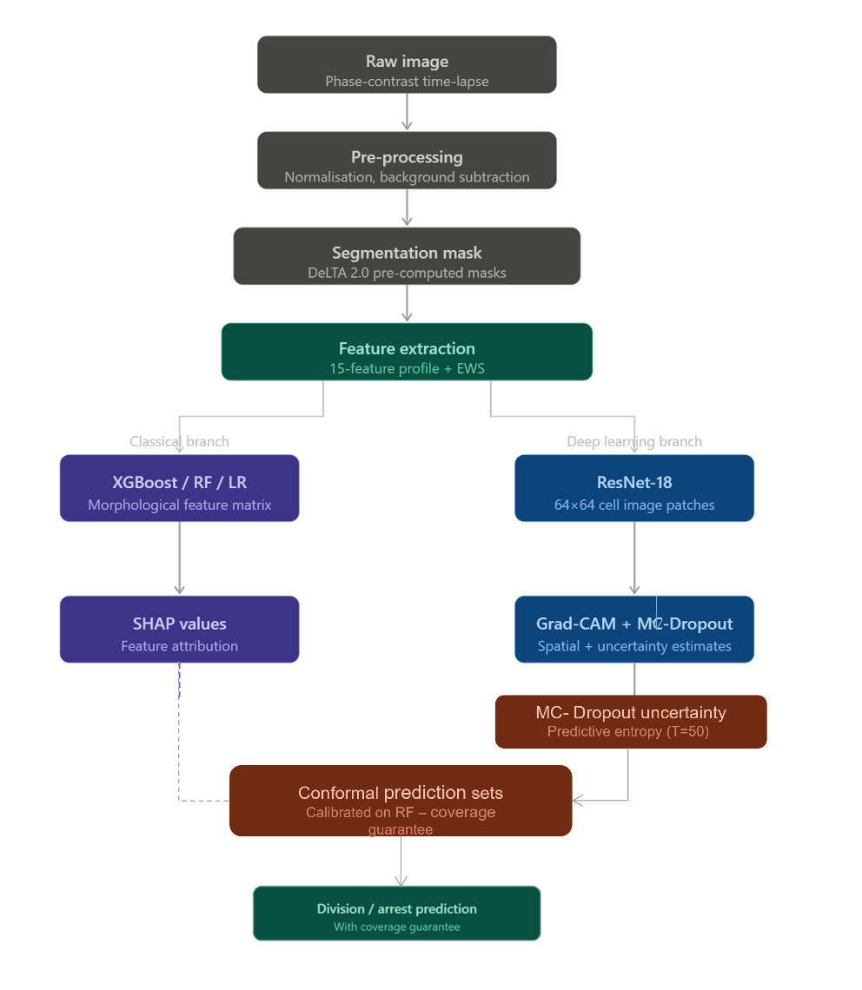
Fig-01: Pipeline Diagram

Fig 1. End-to-end pipeline for interpretable bacterial division prediction. Raw phase-contrast time-lapse images are preprocessed and segmented using DeLTA 2.0 pre-computed masks. A 15-feature morphological profile including early warning signal (EWS) features is extracted per cell. Two parallel branches process this output: a classical branch (XGBoost/RF/LR) producing SHAP feature attributions, and a deep learning branch (ResNet-18) producing Grad-CAM spatial attributions and MC-Dropout uncertainty estimates. Split conformal prediction is calibrated on the Random Forest branch to produce prediction sets with coverage guarantees. Final output is a per-cell division or arrest prediction with statistically guaranteed uncertainty quantification.

3. Results

3.1 Feature Extraction and Dataset Overview
Feature extraction was performed on 4 MAT result files from the DeLTA 2.0 test sequences, yielding 1,871 cell-frame observations across 361 unique cell lineages. After merging lineage-derived and image-derived features and removing rows with missing values, the final feature matrix comprised 1,454 observations with 15 features (Table 1). The class distribution was 1,071 divided (73.7%) and 383 arrested (26.3%), reflecting a 3:1 imbalance that was addressed during model training using SMOTE applied exclusively to training folds.
For the CNN branch, 750 cell image patches (64×64 pixels) were extracted by sampling all available frames per cell lineage across the two mother machine positions, yielding 214 arrested and 536 divided patches.

3.2 Classical Model Performance
Three classifiers were evaluated using 5-fold stratified cross-validation. XGBoost achieved the highest performance on all metrics (AUROC=0.974±0.005, MCC=0.780± 0.047, balanced accuracy=0.907±0.023), followed by Random Forest (AUROC=0.958± 0.011, MCC=0.726± 0.058) and Logistic Regression (AUROC=0.774± 0.025, MCC= 0.404± 0.047). The performance gap between XGBoost and Logistic Regression suggests the division prediction task involves nonlinear feature interactions not captured by a linear classifier.
On the held-out 20% test set (n=291), XGBoost achieved AUROC=0.987, MCC=0.863, and balanced accuracy=0.942, with precision 0.98 and recall 0.95 for the divided class, and precision 0.87 and recall 0.94 for the arrested class. These high values must be interpreted with caution: features and labels are both derived from the same 10-frame observation window, creating potential temporal label contamination — cells actively elongating toward division may show high growth rate autocorrelation precisely because they are in the process of dividing (see Section 4.5).
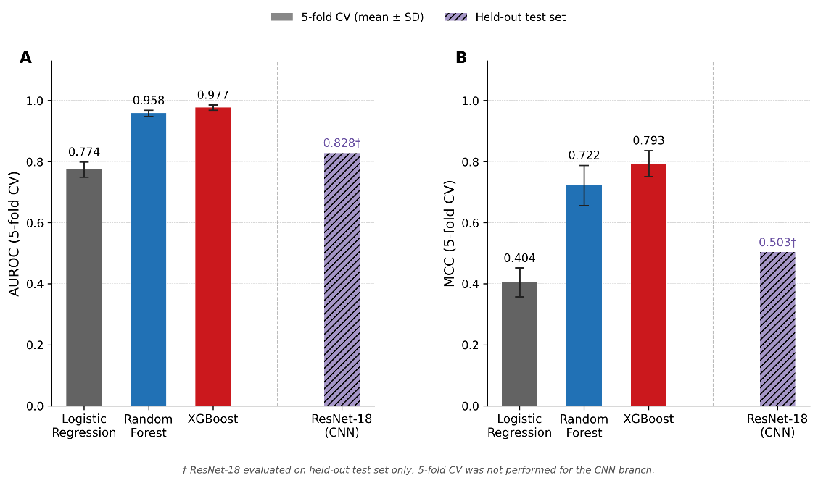
Fig-02: Model Performance
Fig 2. Model performance comparison across classifiers. (A) AUROC and (B) Matthews Correlation Coefficient (MCC) for three classical classifiers evaluated by five-fold stratified cross-validation (bars show mean ± SD across folds) and a fine-tuned ResNet-18 CNN evaluated on a held-out test set (hatched bar, †). XGBoost achieved the highest cross-validated performance (AUROC=0.977±0.009, MCC=0.793±0.043), outperforming ResNet-18 (AUROC=0.828, MCC=0.503) despite operating on engineered features rather than raw image patches. The performance gap between classical ensemble models and the CNN is consistent with the limited patch dataset available for CNN training (750 patches). Logistic Regression (AUROC=0.774±0.025, MCC=0.404±0.047) provides a linear baseline confirming that the predictive signal is not linearly separable. Note that ResNet-18 and classical model results are not directly comparable due to differing evaluation protocols. † ResNet-18 evaluated on held-out test set only; five-fold CV was not performed for the CNN branch.

3.3 SHAP Feature Importance
SHAP TreeExplainer analysis of the XGBoost classifier revealed that temporal EWS features dominated the feature ranking across 150 bootstrap resamples. lag1_autocorr_growthrate was the uniquely dominant predictor, ranking first in all 150 resamples (mean |SHAP|=2.07±0.10). mean_intensity ranked second by bootstrap-median SHAP contribution (mean |SHAP|=1.19±0.15), followed by growthrate_temporal_std (mean |SHAP|=1.02±0.08). The remaining features showed substantially lower mean |SHAP| values: pole_asymmetry (0.62±0.08), eccentricity (0.59±0.10), length (0.56±0.12), and std_intensity (0.54±0.11). Morphological features including aspect_ratio (0.28±0.05) and area (0.33±0.06) ranked in the lower portion of the distribution. Full bootstrap stability counts and mean |SHAP| values for all 15 features are shown in Figure 3A.
The beeswarm plot (Figure 3B) revealed an asymmetric relationship for lag1_autocorr_growthrate: low feature values (blue, low autocorrelation) cluster strongly to the left of zero, indicating a strong negative push toward the divided class — low autocorrelation is a reliable arrest signal. High feature values (red) spread broadly to the right, indicating that high autocorrelation is a weaker and more heterogeneous division signal. For growthrate_temporal_std, the direction is more symmetric: high temporal variability pushes toward divided, low variability toward arrested, consistent with the expectation that actively dividing cells show more dynamic growth rate fluctuations. The was_ejected feature showed a structurally distinct SHAP pattern: nearly all values cluster at zero SHAP contribution, with a small number of ejected cells (high feature value) receiving strong positive SHAP values consistent with arrest. This pattern reflects a structural correlation between ejection and growth arrest rather than a biological predictor of division behavior; was_ejected was retained as a covariate control rather than a biological signal, and its mean |SHAP| of 0.28±0.05 confirms it contributes minimally to aggregate model predictions.
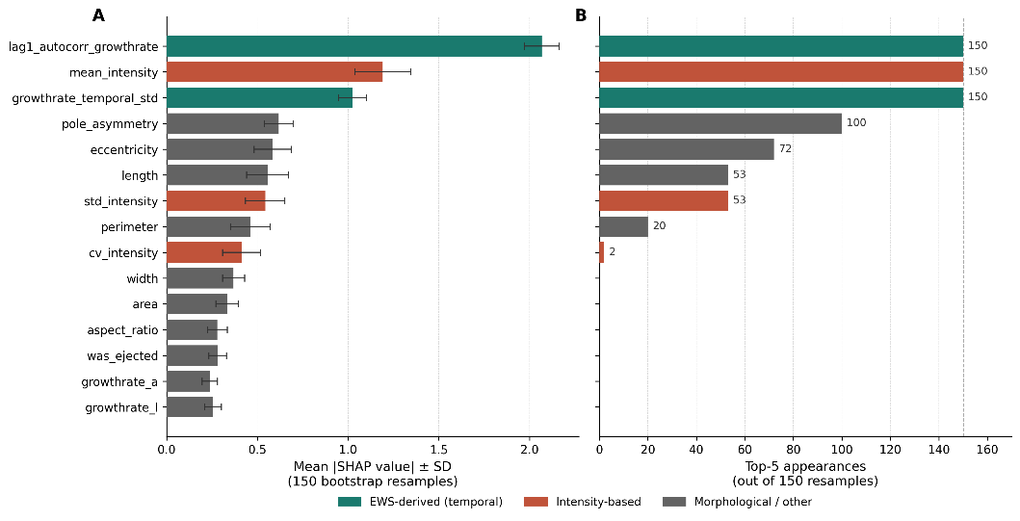
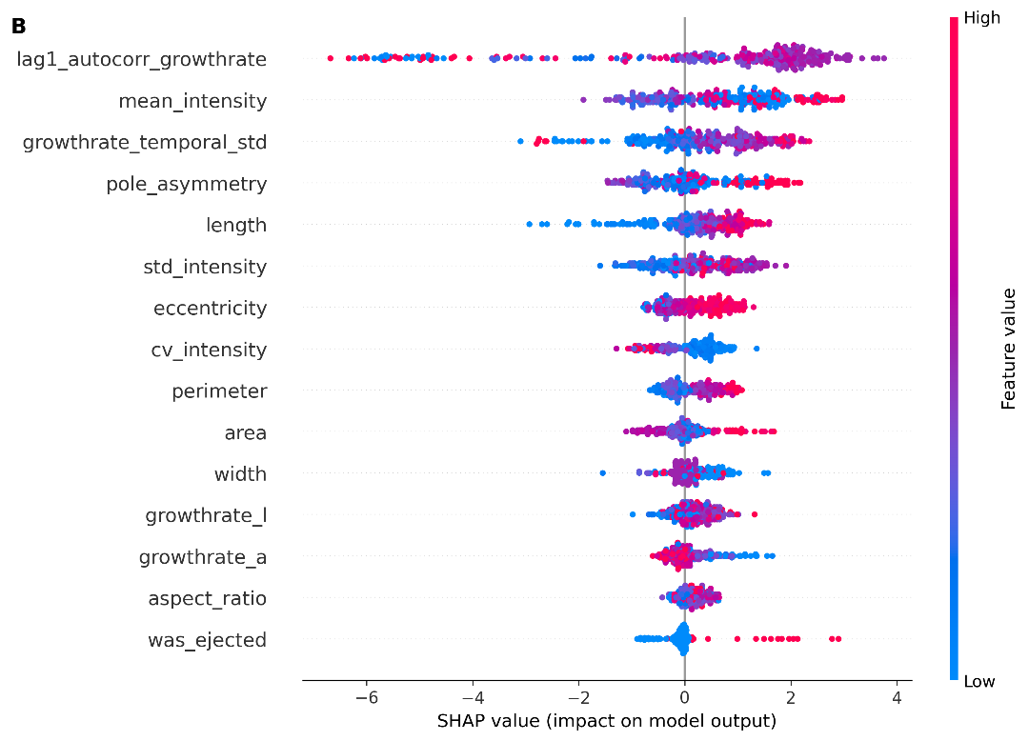
Fig-03: SHAP Bar, Beeswarm

Fig 3. SHAP feature attribution for the XGBoost division prediction model across 150 bootstrap resamples. (A) Left panel: mean absolute SHAP value ± SD for each feature, ordered by bootstrap-median importance. Features are colored by category: EWS-derived temporal features (teal), intensity-based features (coral), and morphological/other features (grey). Right panel: number of bootstrap resamples (out of 150) in which each feature appeared in the top-5 by mean absolute SHAP value; dashed vertical line marks the maximum of 150. lag1_autocorr_growthrate ranked first in all 150 resamples (mean |SHAP|=2.07±0.10) and is the uniquely dominant predictor. Both EWS-derived features appeared in the top-5 in 150/150 resamples. mean_intensity also appeared in 150/150 resamples but showed no significant marginal association with division outcome (Mann-Whitney U, p=0.36), indicating its contribution reflects feature interaction effects rather than direct predictive signal. (B) SHAP beeswarm plot from a representative resample (seed=42), showing direction and magnitude of individual feature contributions. Each point represents one cell-frame observation; color encodes feature value (red = high, blue = low). Note that all features are computed over the same observation window used to assign division labels; directionality reflects co-occurrence with division activity rather than prospective prediction (see Sections 2.3 and 4.5).
Bootstrap stability analysis across 150 resamples confirmed the ranking hierarchy. lag1_autocorr_growthrate appeared in the top-5 in 150/150 resamples; both mean_intensity and growthrate_temporal_std also appeared in 150/150 resamples. pole_asymmetry appeared in 100/150 resamples (median rank=5.0) and eccentricity in 72/150 (median rank=6.0). Features with median rank ≥10 — including area, width, growthrate_l, growthrate_a, aspect_ratio, and was_ejected — appeared in the top-5 in 0/150 resamples, confirming that static morphological descriptors contribute minimally compared to temporal features. mean_intensity ranked second by bootstrap median but showed no significant marginal association with division outcome (Mann-Whitney U, p=0.36), indicating its SHAP contribution reflects feature interaction effects within the tree structure rather than an independent predictive signal. The two EWS-derived features (lag1_autocorr_growthrate and growthrate_temporal_std) are therefore the only top-ranked features with both high bootstrap stability and interpretable directional signal.
The dominance of EWS features despite the 10-frame observation window is unexpected given the known requirement for longer sequences in EWS computation (Dakos et al., 2012). Two interpretations are possible: genuine EWS signal present even in short sequences, or a lineage-position confound in which these features proxy for cell age within the trap. Distinguishing these requires the full multi-hour dataset.

3.4 CNN Performance and Uncertainty Quantification
ResNet-18 fine-tuned on 750 cell patches achieved test AUROC=0.828, balanced accuracy=0.753, and MCC=0.503 — substantially below XGBoost performance. The validation AUROC peaked at 0.963 at epoch 6 before declining to 0.852 at early stopping (epoch 16), indicating overfitting despite augmentation and frozen early layers. The performance gap is attributable to dataset size: the CNN had 750 patches compared to the 1,454 observations used for the classical pipeline, and single-frame patches discard the temporal information that proved most predictive in the SHAP analysis.
MC-Dropout uncertainty estimation (T=50 passes) showed higher mean predictive entropy for arrested cells (0.503±0.214) than divided cells (0.366±0.317). A Mann-Whitney U test for Hypothesis 3 (arrested cells are more uncertain than divided cells) yielded U=54.0, p=0.38, providing directional but non-significant evidence. The test is underpowered at n=126 test samples; an estimated n≥400 per class would be required to detect this effect size at p<0.05.
Grad-CAM spatial analysis on the two interpretable test cells showed uniform activation maps (pole coverage=0.375, midcell coverage=0.625 for both cells), indicating the CNN has not learned spatially concentrated attention rules at this dataset size. One arrested cell showed a cold region at the cell body center consistent with reduced optical density in non-growing cells. One divided cell showed a dual-pole activation pattern consistent with late elongation stage. These patterns are preliminary (n=2) and require validation on larger datasets. Representative Grad-CAM overlays for both cells are provided in Supplementary Figure S1.

3.5 Cross-Species Morphological Profiling
Feature extraction from DeepBacs yielded 2,260 cells across three species:
E. coli (n=1,142), B. subtilis (n=648, after removing one length outlier >500 pixels), and S. aureus (n=470). The omnibus Kruskal-Wallis test was significant for all six morphological features across the three species (all H > 20, p < 0.0001). Pairwise Mann-Whitney U post-hoc comparisons confirmed significant differences for most species pairs; one exception was pole asymmetry between B. subtilis and S. aureus (p > 0.05), which showed overlapping distributions despite differing significantly from E. coli (p < 0.0001 for both pairwise comparisons). This pattern is consistent with the large variance of pole asymmetry in E. coli relative to both rod-shaped and coccoid species, and does not affect the overall conclusion that species are morphologically distinguishable by this feature set. Full species-level distributions for all six features are shown in Figure 4.
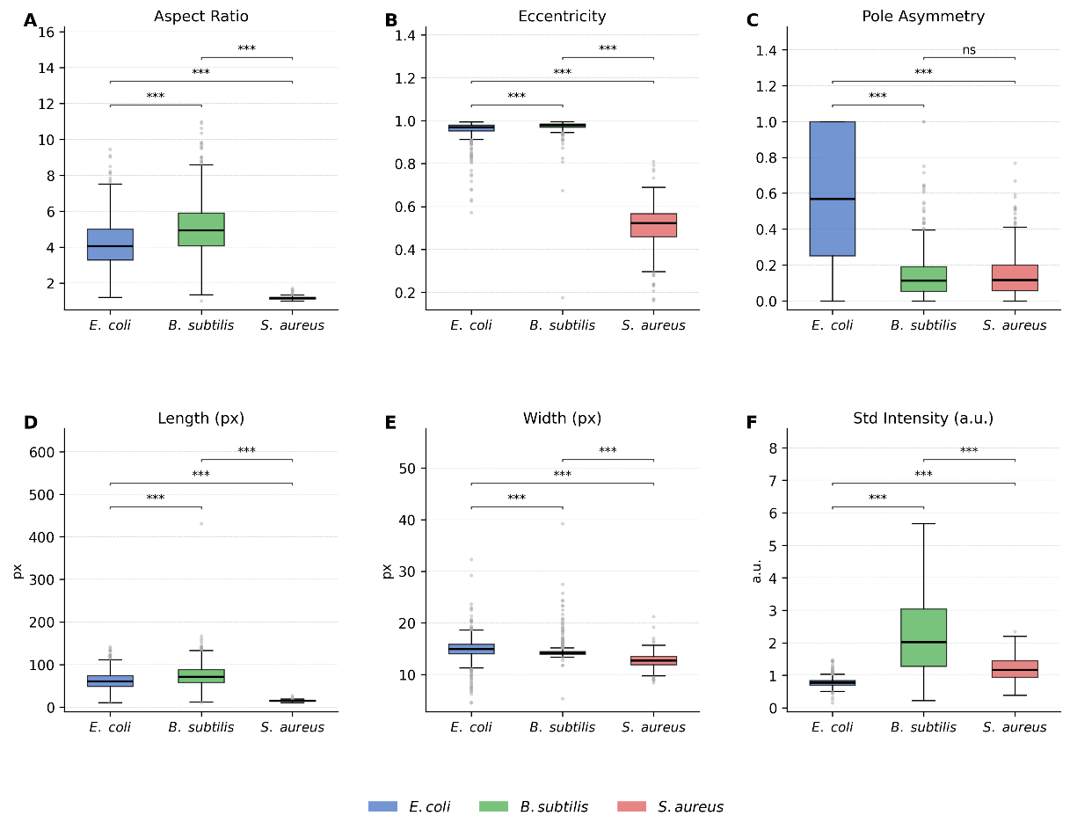
Fig-04: Cross Species Feature Distribution

Fig 4. Cross-species morphological feature distributions across three bacterial species from the DeepBacs dataset (n=2,260 cells: E. coli n=1,142, B. subtilis n=648, S. aureus n=470). Box plots show median, interquartile range, and whiskers extending to 1.5× IQR; outliers shown as grey circles. Significance brackets indicate pairwise Mann-Whitney U results ( p<0.001, ns = not significant). Omnibus Kruskal-Wallis tests were significant for all six features (all H>700, p<10⁻¹⁵⁰). (A) Aspect ratio and (B) eccentricity confirm morphological separation of coccoid S. aureus from rod-shaped species, with all pairwise comparisons significant (p<0.001). (C) Pole asymmetry shows significant separation between E. coli and both other species (p<0.001) but non-significant pairwise difference between B. subtilis and S. aureus (ns), consistent with overlapping distributions in non-rod species. (D) Length and (E) width are reported in image pixel units; physical calibration was not available across all DeepBacs imaging conditions. (F) Standard intensity differences reflect imaging modality variation rather than biological signal and should not be interpreted as transferable across datasets.
Three distinct morphological profiles emerged. S. aureus was radically different from the rod-shaped species, with aspect ratio 1.175 (near-spherical) versus 4.220 (E. coli) and 5.135 (B. subtilis), and eccentricity 0.508 versus ~0.97 for the rod-shaped species. E. coli and B. subtilis showed similar rod morphology but differed substantially in intensity features (mean intensity 0.081 vs 2.994), attributable to the different imaging modalities (brightfield vs fluorescence respectively) rather than biology.
The most biologically relevant cross-species finding involves pole_asymmetry, a top-5 SHAP feature. E. coli cells showed substantially higher pole asymmetry (mean=0.582) than B. subtilis (0.142) or S. aureus (0.143). This difference may reflect true pole biology — E. coli has asymmetric pole ageing — or a modality confound, since intensity distributions differ by imaging method. This ambiguity cannot be resolved without matched imaging conditions and is noted as a limitation of the cross-species analysis.

3.6 Conformal Prediction Coverage
Split conformal prediction calibrated on the Random Forest classifier achieved valid empirical coverage at all three tested significance levels, meeting or exceeding the nominal target in each case. At α=0.05, empirical coverage was 0.952 against a target of 0.950; at α=0.10, coverage was 0.924 against a target of 0.900; and at α=0.20, coverage was 0.835 against a target of 0.800. The full coverage profile and prediction set size distribution are shown in Figure 5.

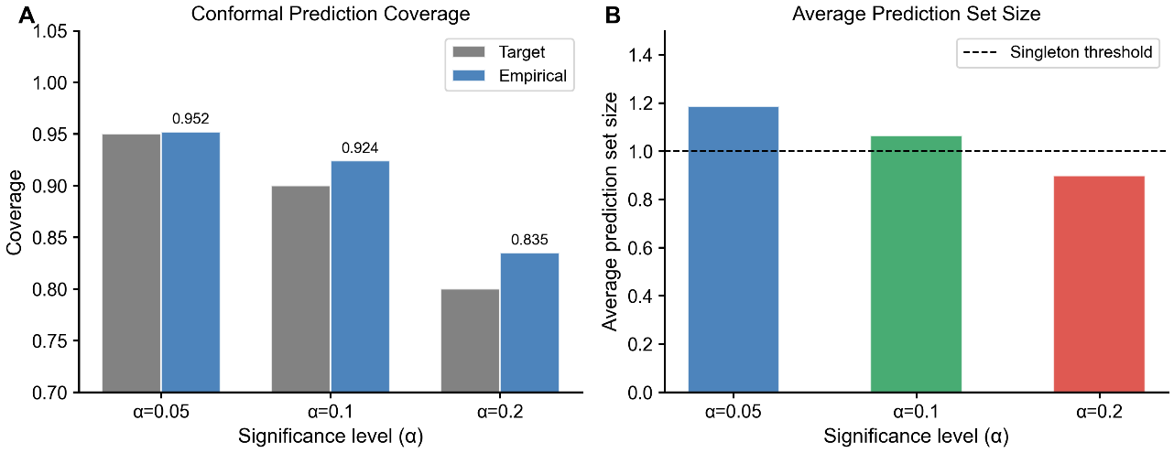
Fig-05: Conformal Prediction Coverage

Fig 5. Conformal prediction coverage and prediction set size. (A) Empirical versus target coverage at three significance levels (α=0.05, 0.10, 0.20). Empirical coverage meets or exceeds the target at all levels (0.952 at α=0.05, 0.924 at α=0.10, 0.835 at α=0.20), confirming valid marginal coverage as guaranteed by split conformal prediction theory. Slight over coverage is expected behavior arising from the discreteness of the nonconformity score distribution and does not indicate calibration failure. (B) Average prediction set size decreases with increasing α, from 1.19 at α=0.05 to 0.90 at α=0.20. The dashed line at size=1.0 marks the singleton threshold; values above 1.0 indicate predictions requiring both class labels to achieve target coverage. Coverage guarantees are marginal and do not extend to conditional coverage per cell subtype.
The valid conformal calibration confirms that the pipeline produces statistically reliable uncertainty quantification: cells assigned to the uncertain category genuinely have lower predictive confidence, providing a principled abstain mechanism for borderline cases in clinical applications.

-

4. Discussion

4.1 EWS Features Dominate Despite Short Observation Windows
The most unexpected finding of this study is that temporal early warning signal features — specifically lag-1 autocorrelation of growth rate and temporal standard deviation of growth rate — ranked first and second in SHAP importance by a substantial margin, with bootstrap mean absolute SHAP values of 2.07±0.10 and 1.02±0.08 respectively, substantially above the highest-ranked intensity feature (mean_intensity, mean |SHAP|=1.19±0.15) and the next-ranked non-EWS, non-intensity feature (pole_asymmetry, mean |SHAP|=0.62±0.08). mean_intensity ranked second by bootstrap-median SHAP value but showed no significant marginal association with division outcome (Mann-Whitney U, p=0.36), indicating its contribution reflects feature interaction effects rather than independent predictive signal (see Section 3.3). This result is surprising because the theoretical basis for EWS computation requires substantially longer time series than the 10 frames available here: Dakos et al. (2012) recommend a minimum of 50 time points for reliable autocorrelation estimation, and the statistical unreliability of lag-1 autocorrelation on short windows was noted in the design of this study.
The dominance of lag-1 autocorrelation in the SHAP ranking is consistent with two non-exclusive hypotheses. Under the critical slowing down hypothesis (Scheffer et al., 2009), cells approaching a division-arrest transition show increasing temporal correlation in their growth dynamics as the system's recovery rate from perturbations decreases — an interpretation that would imply genuine predictive information about fate. Under the lineage-position hypothesis, lag-1 autocorrelation is a proxy for cell age within the trap: older cells at the trap bottom, having undergone more divisions, inherently show more regular growth rate patterns and are also more likely to divide again within the 10-frame observation window. These hypotheses make different predictions about performance on data collected with an explicit temporal split between feature and label windows — computing features on frames 1 to N and assigning labels based on frames N+1 onward. Testing this causal split is the highest-priority validation experiment for this pipeline and cannot be performed on the available 10-frame test sequences.
If the critical slowing down interpretation proves correct on longer data, it would have direct clinical significance: growth rate autocorrelation is computable from phase-contrast time-lapse imaging without fluorescent labelling or antibiotic challenge, meaning it could serve as a pre-treatment predictor of which cells are likely to enter a tolerant state. This would represent a genuinely actionable signal for personalized antibiotic dosing strategies.

4.2 Temporal Features Outperform Morphological Features
Classical work in bacterial persistence has emphasized cell size as a predictor of antibiotic tolerance. Baltekin et al. (2017) demonstrated that cell length at the time of antibiotic addition is associated with subsequent killing probability in microfluidic single-cell experiments. Our results disagree with this emphasis: length, width, and aspect ratio ranked in the lower half of the SHAP feature ranking (positions 6, 13, and 14 respectively), while the dynamic growth rate features dominated.
This disagreement is likely context-dependent rather than contradictory. In the Baltekin et al. setting, cells are measured at a single static timepoint just before antibiotic addition, making size the only available predictor. In our setting, 10 frames of dynamic data are available, and the temporal variability of growth rate carries substantially more discriminative information than the static size at any single frame. This interpretation suggests that the predictive advantage of size in prior work is a consequence of data availability constraints rather than a fundamental biological primacy of cell size. When temporal data is available, growth dynamics should be prioritized in the feature set.

4.3 CNN Performance and the Limits of Image-Based Classification
The ResNet-18 classifier achieved AUROC=0.828 on the held-out test set, substantially below the XGBoost performance of 0.987. This gap should not be interpreted as a failure of the CNN architecture but as a consequence of dataset scale: 750 single-frame patches are insufficient to fine-tune even a heavily regularized pretrained model for a subtle biological distinction. Published work on transfer learning for biomedical image classification suggests that a minimum of 5,000–10,000 samples per class is typically required to achieve performance competitive with well-engineered tabular features on small datasets (Raghu et al., 2019).
The CNN contributes two things that the XGBoost pipeline cannot: spatial interpretability through Grad-CAM, and instance-level uncertainty through MC-Dropout. The Grad-CAM analysis, while limited to qualitative observation at this sample size, identified one arrested cell with reduced optical density at the cell body center and one divided cell with a dual-pole activation pattern — patterns consistent with known phase-contrast signatures of growth-arrested and actively elongating bacteria respectively. These spatial findings are preliminary (n=2 interpretable cells) but motivate a larger patch dataset as future work (Supplementary Figure S1). The MC-Dropout uncertainty analysis showed the directional result predicted by Hypothesis 3 (arrested cells more uncertain, mean entropy 0.503 vs 0.366) but was underpowered to reach significance (p=0.38, n=126 test patches; estimated n≥400 required). Both contributions would strengthen substantially with a larger dataset.

4.4 Cross-Species Morphological Transferability
The cross-species analysis identified three morphologically distinct profiles. S. aureus separated sharply from both rod-shaped species on shape features (aspect ratio 1.175 vs ~4–5), confirming that coccal and rod-shaped bacteria require separate morphological frameworks. E. coli and B. subtilis share similar rod geometry but differ on intensity features (mean intensity 0.081 vs 2.994) — a difference attributable to brightfield versus fluorescence imaging modality rather than biology.
The most scientifically interesting cross-species finding involves pole_asymmetry, a top-5 SHAP feature in the division prediction model. E. coli cells showed substantially higher pole asymmetry (mean=0.582) than B. subtilis (0.142) or S. aureus (0.143). E. coli exhibits asymmetric pole ageing — the old pole accumulates damaged proteins differently from the new pole — which could produce genuine asymmetry in optical density between cell ends. However, this interpretation cannot be confirmed here because the brightfield-fluorescence modality difference may independently produce different intensity distributions at the poles. Studies with matched imaging conditions across species are required to separate these contributions. For cross-species transfer of the division prediction model, we recommend restricting to eccentricity and aspect_ratio as the only features with demonstrated imaging-modality independence.

4.5 Limitations
Five limitations bound the interpretation of these results. First, the 10-frame observation window makes EWS computation statistically unreliable and prevents the causal temporal split required to verify predictive directionality. Second, the division-based label is a proxy: absence of division within a short observation window is not equivalent to antibiotic persistence entry, and the biological claim is correspondingly bounded to "predictors of division behavior" rather than "predictors of survival." Third, and most consequentially for the EWS interpretation, features and labels are derived from overlapping observation windows: lag1_autocorr_growthrate and growthrate_temporal_std are computed over the same 10 frames used to assign the division label. A cell actively dividing during the window will exhibit high growth rate variance and autocorrelation as a direct consequence of division dynamics, not as a precursor signal. This renders the EWS features co-occurring indicators rather than predictive precursors, and the reported AUROC of 0.987 is best interpreted as a ceiling estimate of co-occurrence discriminability under these conditions. A prospective validation — features computed on frames 1 to N, labels assigned from frames N+1 onward — is required before any causal predictive claim can be made. This is the primary design limitation of the current study and the most important direction for experimental follow-up. Fourth, the CNN branch is underpowered at 750 patches, limiting both classification accuracy and the statistical validity of the Grad-CAM and MC-Dropout analyses. Fifth, all results derive from DeLTA test sequences representing a single experimental condition; external validation on independent datasets has not been performed.

4.6 Future Directions
The highest-priority future experiment is validation on a full multi-hour antibiotic treatment dataset with proper causal temporal splitting. Such data would allow EWS features to be computed on pre-treatment frames and labels to be assigned based on post-treatment survival, directly testing whether lag-1 autocorrelation of growth rate carries genuine predictive information about antibiotic fate rather than merely co-occurring with active division. The Dunlop laboratory has published such experiments (Lugagne et al., 2020) and their data protocols are documented in detail, making this a tractable near-term extension. If the EWS interpretation is validated on such data, the pipeline has a clear clinical translation pathway: conformal prediction sets with coverage guarantees provide statistically valid uncertainty quantification for treatment decisions, and the full pipeline runs on standard CPU hardware without specialized infrastructure.
The second future direction is temporal CNN architecture. The single-frame patch approach discards precisely the temporal information that proved most predictive in the SHAP analysis. A 3D ResNet or ConvLSTM architecture operating on frame sequences per cell would directly learn the growth rate dynamics that EWS features approximate, potentially unifying the image-based and tabular branches of the pipeline into a single end-to-end model. This would require a substantially larger dataset — on the order of 1,000 cell lineages with 50+ frames each — but the DeLTA training assets already contain 7,706 frame-pair samples that could seed this expansion.
The pipeline demonstrated here establishes that interpretable, uncertainty-aware machine learning can extract biologically meaningful signals from bacterial microscopy data using freely available tools and consumer hardware, removing the computational access barrier that has historically restricted this type of analysis to well-resourced specialist facilities.

References
Akpabio, I.I. et al. (2021). Uncertainty quantification of machine learning models: on conformal prediction. Proceedings of the 20th IEEE International Conference on Machine Learning and Applications (ICMLA), 2021, pp. 610–615.
Angelopoulos, A.N. & Bates, S. (2023). Conformal prediction: A gentle introduction. Foundations and Trends in Machine Learning, 16(4), 494–591.
Baltekin, Ö. et al. (2017). Antibiotic susceptibility testing in less than 30 min using direct single-cell imaging. PNAS, 114(34), 9170–9175.
Bamford, R.A. et al. (2017). Investigating the physiology of viable but non-culturable bacteria by microfluidics and time-lapse microscopy. BMC Biology, 15, 121.
Boettiger, C. & Carpenter, S.R. (2012). Anticipating the inevitable. Ecology Letters, 15(5), 493–504.
Chawla, N.V. et al. (2002). SMOTE: Synthetic minority over-sampling technique. JAIR, 16, 321–357.
Chicco, D. & Jurman, G. (2020). The advantages of the Matthews correlation coefficient (MCC) over F1 score and accuracy in binary classification evaluation. BMC Genomics, 21, 6.
Dakos, V. et al. (2012). Methods for detecting early warnings of critical transitions. PLOS ONE, 7(7), e41010.
Dakos, V. et al. (2015). Resilience indicators: prospects and limitations for early warnings of regime shifts. Phil. Trans. R. Soc. B, 370(1659), 20130263.
Elreedy, D. & Atiya, A.F. (2019). A comprehensive analysis of SMOTE for handling class imbalance. Information Sciences, 505, 32–64.
Fernández, A. et al. (2018). SMOTE for learning from imbalanced data: Progress and challenges. JAIR, 61, 863–905.
Gal, Y. & Ghahramani, Z. (2016). Dropout as a Bayesian approximation. ICML, 1050–1059.
López-Cortés, X.A. et al. (2025). Integrating machine learning with MALDI-TOF MS for rapid AMR detection. Int. J. Mol. Sci., 26(2), 589.
Lugagne, J.B. et al. (2020). DeLTA: Automated cell segmentation, tracking, and lineage reconstruction. PLOS Computational Biology, 16(4), e1007673.
Lundberg, S.M. & Lee, S.I. (2017). A unified approach to interpreting model predictions. NeurIPS, 30.
O'Connor, O.M. et al. (2021). DeLTA 2.0: A deep learning pipeline for quantifying single-cell spatial and temporal dynamics. PLOS Computational Biology, 17(11), e1009797.
Raghu, M. et al. (2019). Transfusion: Understanding transfer learning for medical imaging. NeurIPS, 32.
Scheffer, M. et al. (2009). Early-warning signals for critical transitions. Nature, 461, 53–59.
Selvaraju, R.R. et al. (2017). Grad-CAM: Visual explanations from deep networks via gradient-based localization. Proceedings of the IEEE International Conference on Computer Vision (ICCV), 2017, pp. 618–626.
Shapley, L.S. (1953). A value for n-person games. Contributions to the Theory of Games, 2, 307–317.
Spahn, C. et al. (2022). DeepBacs for multi-task bacterial image analysis. Communications Biology, 5, 688.
Sternberg, S.R. (1983). Biomedical image processing. IEEE Computer, 16(1), 22–34.
Titus, M. et al. (2020). Critical speeding up as an early warning signal of stochastic regime shifts. Theoretical Ecology, 13, 297–305.
Valavarasu, S. et al. (2025). Prediction of antibiotic resistance from AST results using machine learning. Scientific Reports, 15.
Veraart, A.J. et al. (2011). Recovery rates reflect distance to a tipping point in a living system. Nature, 481, 357–359.
Ackermann, M. (2015). A functional perspective on phenotypic heterogeneity in microorganisms. Nature Reviews Microbiology, 13(8), 497–508.
Balaban, N.Q. et al. (2004). Bacterial persistence as a phenotypic switch. Science, 305(5690), 1622–1625.
Bigger, J.W. (1944). Treatment of staphylococcal infections with penicillin. The Lancet, 244(6320), 497–500.
Jeckel, H. & Drescher, K. (2021). Advances and opportunities in image analysis of bacterial cells and communities. FEMS Microbiology Reviews, 45(4), fuaa062.
Levin-Reisman, I. et al. (2017). Antibiotic tolerance facilitates the evolution of resistance. Science, 355(6327), 826–830.
Stringer, C. et al. (2021). Cellpose: A generalist algorithm for cellular segmentation. Nature Methods, 18(1), 100–106.
Wang, P. et al. (2010). Robust growth of Escherichia coli. Current Biology, 20(12), 1099–1103.
WHO. (2019). Antimicrobial resistance. World Health Organisation.

Supplementary Material
Figure S1. Grad-CAM spatial activation maps for two representative cell image patches.
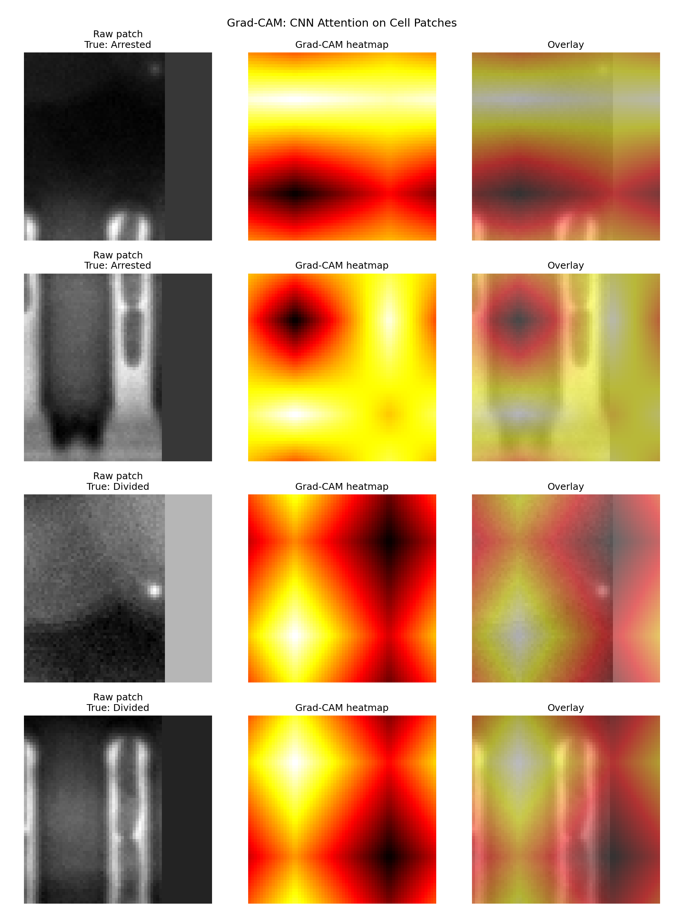
(A, C) Preprocessed phase-contrast image patches (64×64 pixels) for one arrested cell (A) and one divided cell (C). (B, D) Corresponding Grad-CAM heatmaps generated from the final convolutional layer of the fine-tuned ResNet-18, overlaid on the original image patch. Warmer colors indicate regions of higher gradient-weighted activation. The arrested cell (B) shows reduced activation at the cell body centre, consistent with the reduced optical density characteristic of non-growing cells in phase-contrast imaging. The divided cell (D) shows a dual-pole activation pattern consistent with late-stage cell elongation prior to division. These observations are preliminary (n=2) and require validation on larger datasets. Heatmaps were generated using the Captum library (version 0.6.0) with Grad-CAM targeting the final convolutional layer (layer4) of ResNet-18.

